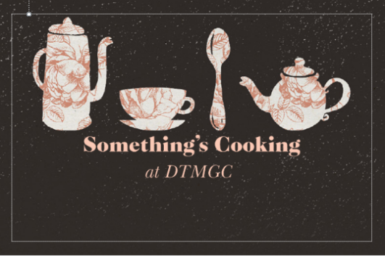

Cold Buffet Menu 2 - £10.45 pp
Selection of cold sandwiches
On white & brown bread

Selection of Savoury Pies
Coleslaw
Sausage Rolls
Potato Salad
Pasta Salad
Homemade Quiche
Variety of Regional Cheeses with Biscuits
Rice Salad
Marinated Chicken Drumsticks
Scotch Eggs
Hand Cut Chips
***********************************
Selection of Desserts – extra £1.50 pp
**********************************
Unlimited Tea & Coffee - £1.00 pp
(Other options available on request)

