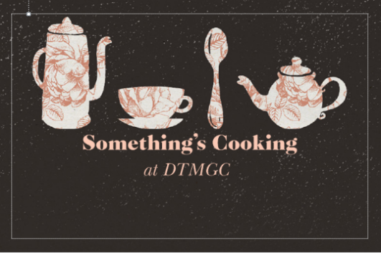

Hot Buffet Menu 1 - £13.00 pp

Choice of Two Roast Meats
Served with appropriate accompaniments and meaty gravy
(Vegetarian options available)

Yorkshire Puddings
Stuffing
Roast and Mashed Potatoes
Selection of Vegetables

************************
Cold Pudding
Or
Hot Pudding

************************

Unlimited Tea & Coffee - £1.00 pp

